Level 2 – Process Investigation (Tasks 21–40)
Task 21 – List All Running Processes
Scenario
A SIEM alert indicates suspicious activity on a Windows endpoint.
Objective
View all running processes.
Command
Get-Process
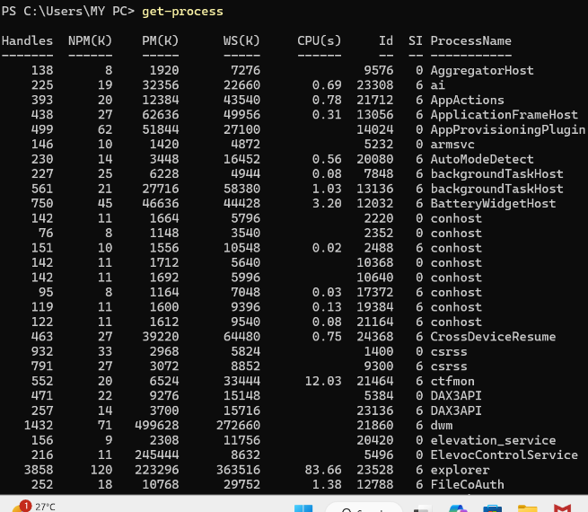
SOC Perspective
The first step during an investigation is to identify all running processes.
Look For
- Unknown process names
- Duplicate system processes
- High CPU usage
- High memory usage (ws)– 300-500 mb se uppar nahi jaani chaiye
- PM- vo data jo move kar sakta hai disk mai jab ram full
- Npm – jo nahi kar sakta disk mai move
- Handle- resource kitne use huye hai yeh battana hai
- 0 means background services

Task 22 – Find a Specific Process
Objective
Check whether Chrome is running.
Command
Get-Process chrome
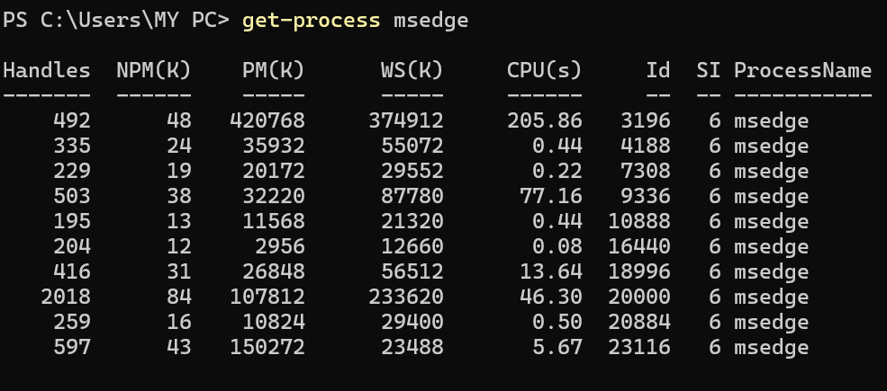
SOC Perspective
Sometimes SIEM alerts mention a process name.
Verify whether it is currently running.
Suspicious Indicators
- Process not expected on the system
- Unknown executable

Task 23 – Sort Processes by CPU Usage
Command
Get-Process | Sort-Object CPU -Descending
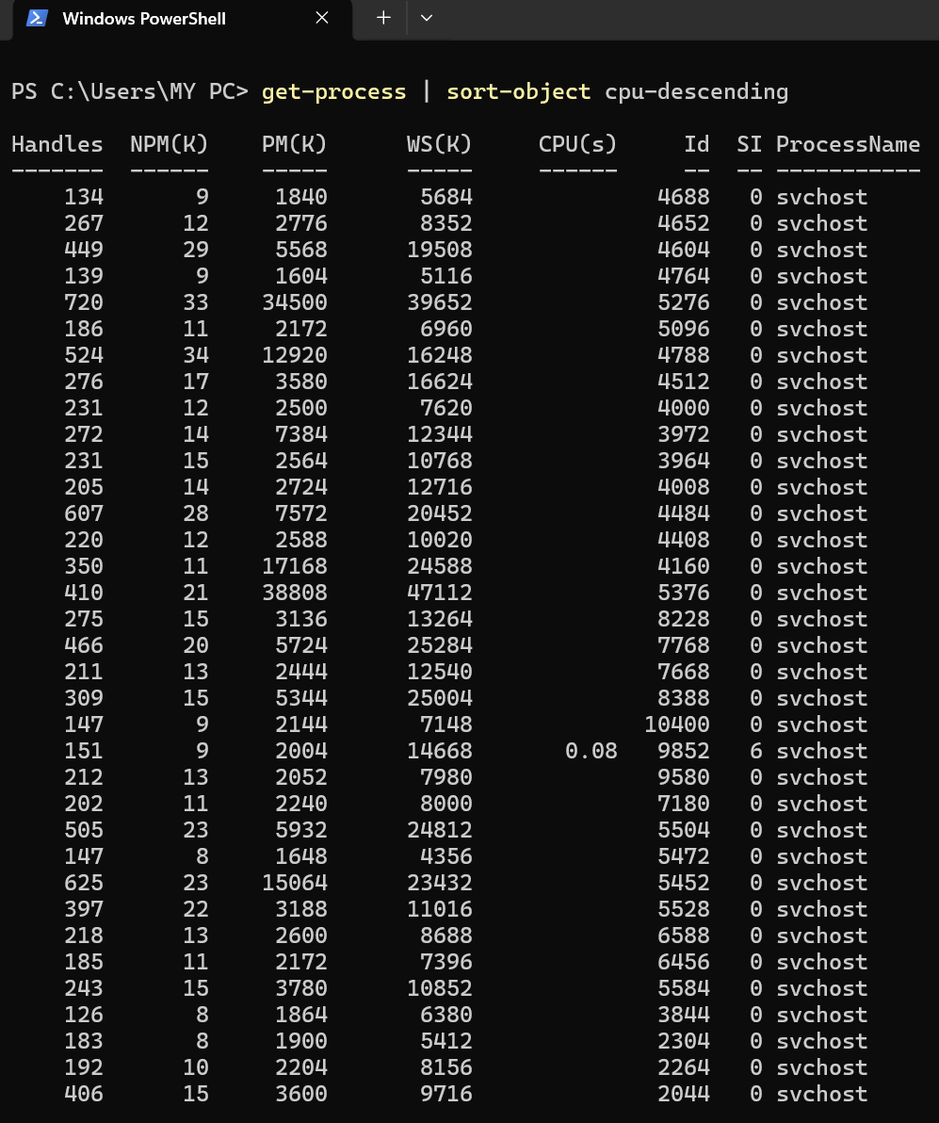
SOC Perspective
Malware often consumes high CPU while:
- Encrypting files
- Mining cryptocurrency
- Running malicious scripts
Investigate
Top 5 CPU-consuming processes.
So basically hum chek karte hai ki konsa process kitna cpu use kar raha hai high usge without actual usage of any application is suspicious

Task 24 – Sort Processes by Memory Usage
Command
Get-Process | Sort-Object WS -Descending
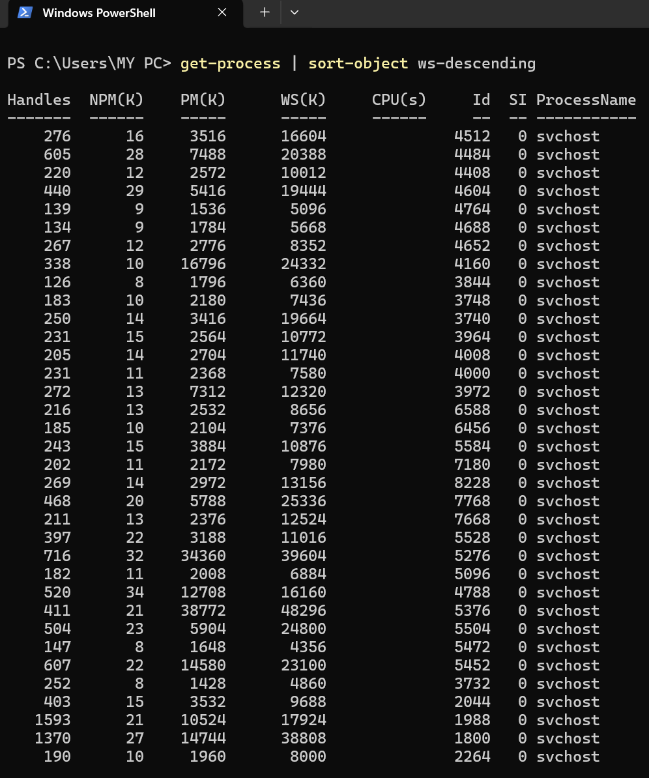
SOC Perspective
High memory consumption may indicate:
- Malware
- Memory injection
- Browser abuse
- Crypto miners

Task 25 – Find Process by PID
Command
Get-Process -Id 1234
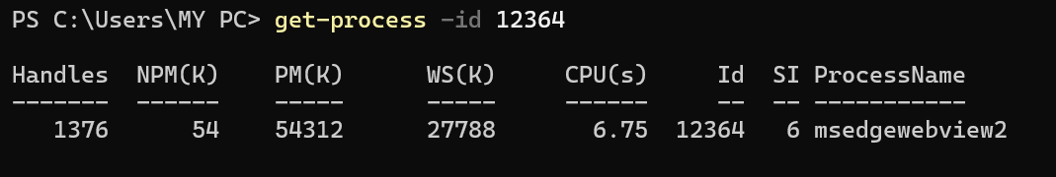
Replace 1234 with a real PID from Task 21.
SOC Perspective
SIEM alerts often include a Process ID (PID).
Analysts verify the process associated with that PID.

Task 26 – Count Running Processes
Command
(Get-Process).Count
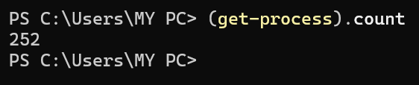
SOC Perspective
Unexpectedly high process counts may indicate:
- Malware
- Runaway applications
- Malicious scripts
Normal count if freshly boot – 100-150
Daily usage – 180-250+

Task 27 – Display Process Path
Command
Get-Process chrome | Select Name,Path
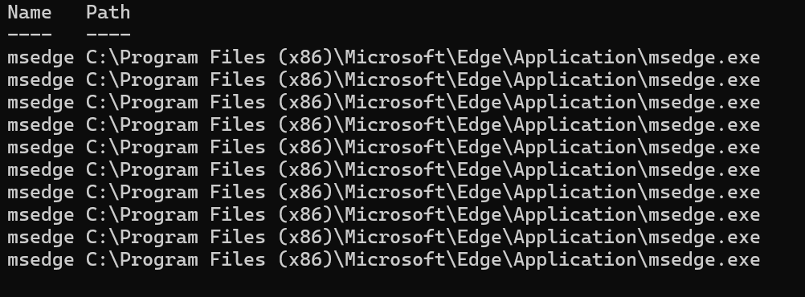
SOC Perspective
The executable path helps determine whether a process is legitimate.
Safe Example
C:\Program Files\Google\Chrome\
Suspicious Example
C:\Users\User\AppData\Roaming\

Task 28 – Display Company Information
Command
Get-Process chrome | Select Company,Product
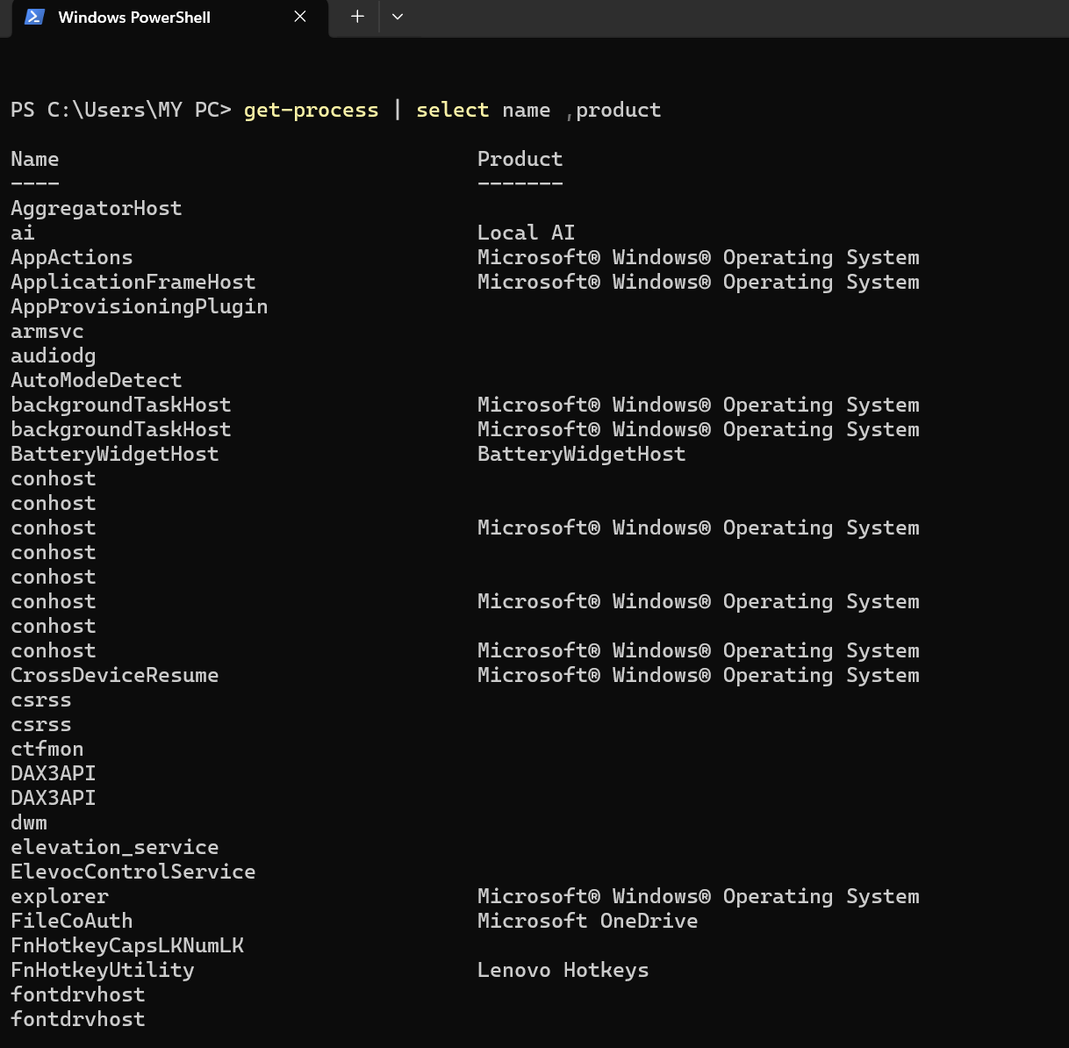
SOC Perspective
Legitimate software usually has a trusted publisher.
Unknown publishers require investigation.

Task 29 – Stop a Process
⚠️ Practice only with Notepad.
Open Notepad first.
Command
Stop-Process -Name notepad
SOC Perspective
During Incident Response, analysts terminate malicious processes to contain an attack.
Never stop critical Windows processes.

Task 30 – Find Processes Started Recently
Command
Get-Process | Sort-Object StartTime -Descending
SOC Perspective
Useful after malware execution.
Investigate processes that started around the alert timestamp.

Task 31 – View Process Details
Command
Get-Process chrome | Format-List *
SOC Perspective
Collect detailed process information during investigations.
Bas teen cheeze dekho id , memory usage (ws), path

Task 32 – Display Process Owner
Command
Get-CimInstance Win32_Process | Select Name,ProcessId
SOC Perspective
Determine which user launched the process.

Task 33 – Search Processes by Name
Command
Get-Process *note*
SOC Perspective
Useful when only part of the process name is known.

Task 34 – Group Processes by Name
Command
Get-Process | Group-Object ProcessName
SOC Perspective
Multiple instances of the same process may indicate suspicious behavior.

Task 35 – Export Process List
Command
Get-Process > ProcessList.txt
SOC Perspective
SOC analysts preserve evidence before taking action.

Task 36 – Export Process Details
Command
Get-Process | Export-Csv ProcessList.csv -NoTypeInformation
SOC Perspective
CSV reports are useful for documentation and incident reporting.

Task 37 – Find Processes by CPU Time
Command
Get-Process | Sort CPU -Descending | Select -First 10
SOC Perspective
Investigate resource-intensive processes.

Task 38 – Find Processes by Working Set
Command
Get-Process | Sort WS -Descending | Select -First 10
SOC Perspective
High memory usage may indicate malicious behavior.

Task 39 – Search for PowerShell Processes
Command
Get-Process powershell
SOC Perspective
Attackers frequently abuse PowerShell.
Unexpected PowerShell processes deserve attention.

Task 40 – Investigate a Process
Choose any process from Task 21 and answer:
- Process Name
- PID
- Company
- Path
- CPU Usage
- Memory Usage
- Legitimate or Suspicious?
- Why?

